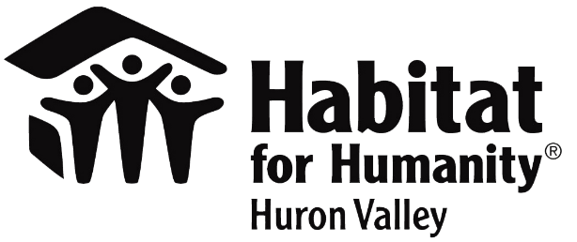
Contact
Nancy Biehn
Habitat for Humanity of Huron Valley
734 800-4221
nbiehn@h4h.org
www.h4h.org

LOCAL CRAFT BEVERAGE MAKERS HOST EVENTS TO SUPPORT HABITAT FOR HUMANITY OF HURON VALLEY’S HOUSE THAT BEER BUILT
ANN ARBOR (July 2022) Several area local breweries and craft beverage makers joined together to support Habitat for Humanity of Huron Valley’s (HHHV) House that Beer Built. During these warm summer months, HHHV is highlighting local partners who are working hard to keep delicious cold beverages flowing for the community’s enjoyment and allowing some of the proceeds to flow into a House that Beer Built for one local homeowner.
For the last four years, local craft beverage makers have united to help raise money to build a house for a local family or individual in need. Through whatever means works best for each business, they committed and worked toward raising funds for a house. This year these partners have pledged to donate over $8,000 and will provide volunteers to help build a Habitat house in our community. Despite residual challenges of the pandemic such as staff in short supply and rising costs, HHHV would like to recognize these fantastic local partners. They give back to the community in multiple ways and have earned the community’s support.
The community can support this year’s House That Beer Built by making a gift at www.h4h.org/housethatbeerbuilt.
Here is the list of this year’s House That Beer Built partners. Some have completed their fundraising and others are in progress:
Erratic Ale Co. in Dexter – Designated Habitat as the recipient of a Good Neighbor Tap in April
Arbor Brewing - Corner Brewery in Ypsilanti and Tap Room in Plymouth – Giving a percentage of their sales of a seasonal selection beer
Unity Vibrations Kombucha in Ypsilanti – Created a special recipe beer called “Kombucha Kickback” with 100% of sales going to Habitat
Witch’s Hat in South Lyon – Selling 10 lifetime memberships of their mug club and giving 100% of the proceeds to Habitat
Miss Kim in Ann Arbor – donating 20% of the profits from three specialty beers all summer.
Ypsilanti Cocktail Club in Ypsilanti – Added “Summer Habitat” a new cocktail to their summer menu with $1 from each cocktail benefiting Habitat.
Habitat for Humanity of Huron Valley builds homes, communities, and hope… under one roof. We work to enrich Washtenaw County through a legacy of affordable homeownership for families and individuals of low income. Each year, Habitat serves and assists families and individuals in Washtenaw County through its Home Ownership Program, Home Improvement Program, Veterans Program, and Community Development Program. Habitat has built or renovated over 250 homes and served or assisted more than 5,000 households in Washtenaw County. For more information, visit www.h4h.org.
###

