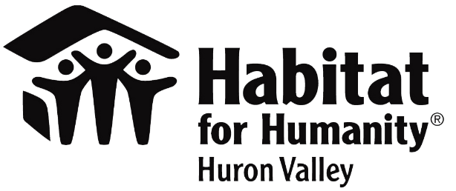
Contact
Alison Oumedian
Habitat for Humanity of Huron Valley
734-882-2009
alison@h4h.org
www.h4h.org

FOR IMMEDIATE RELEASE
IN RECOGNITION OF AMERICAN CRAFT BEER WEEK HABITAT HIGHLIGHTS LOCAL BREWERIES FOR THEIR PARTNERSHIPS & ENCOURAGES COMMUNITY SUPPORT

ANN ARBOR (May 6, 2021) May 10-16, 2021 is American Craft Beer Week and with the current economy, and the statewide orders, Habitat for Humanity of Huron Valley would like to acknowledge the wonderful support of this year’s House That Beer Built partners. During this week we would like to call attention to our local partners who can now use the support of our community.
For the last three years local breweries have united to help raise money to build a house for a local family in need. Through whatever means work best for each brewery, they committed and worked toward raising nearly $20,000 over the last three years and provided volunteers to physically build the home. This year we have a couple breweries who once again agreed to help even while struggling to stay cash positive. Habitat would like to recognize these fantastic local partners. They give back to the community in multiple ways and are now in need of the same support.
People can support this year’s House That Beer Built by making a gift at www.h4h.org/housethatbeerbuilt.
Below is a list of this year’s House That Beer Built partners and ways to support.
Corner Brewery – Selling pin-up houses for a donation to show your support in the brewery.
HOMES Brewery – Look for designated tap selections and other specials in support of Habitat.
Established in 1989, Habitat for Humanity of Huron Valley enriches our neighbors to build better neighborhoods through our volunteer, donation, partnership and ReStore efforts. We build homes, communities and hope… under one roof. We work to enrich Washtenaw County through a legacy of affordable homeownership for families and individuals of low income. Each year, Habitat serves or assists more than 1,000 families and individuals through its Home Ownership Program, Home Improvement Program, Veterans Program, Financial Education and Community Development Program. Habitat has built or renovated nearly 250 homes and served or assisted more than 5,000 households in Washtenaw County. For more information, visit www.h4h.org.
###

