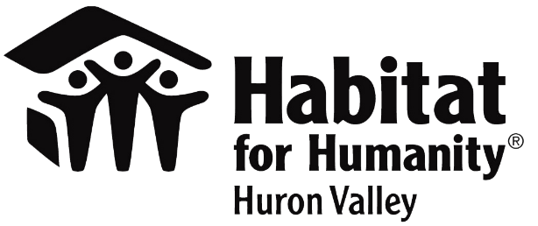
Contact
Laura Town
Habitat for Humanity of Huron Valley
248-884-7325
ltown@h4h.org
www.h4h.org
Lysa Davis
University Bank
734-224-4262
ldavis@university-bank.com
www.university-bank.com

FOR IMMEDIATE RELEASE
IN RECOGNITION OF NATIONAL HOMEOWNERSHIP MONTH HABITAT HIGHLIGHTS LOCAL PARTNERSHIP WITH UNIVERSITY BANK

ANN ARBOR (June 2022) June is National Homeownership Month and during this month we would like to highlight the wonderful support we have received from University Bank. University Bank has been a supporter of Habitat for Humanity of Huron Valley since 2016. However, in the last two years they have chosen to support us with more substantial funding donating over $100,000.
In the next few months, employees of University Bank will be joining us to provide volunteers to physically build a house. University Bank also assists with our home buying process and with our financial education.
We are so grateful for the tremendous support from this local community partner, and we look forward to extending this partnership into the future.

About National Homeownership Month
National Homeownership Month is in June. It celebrates the value that owning a home brings to families, communities, and neighborhoods across America. By becoming a homeowner, people get a step closer to the American dream. This month also shares the joys of being a homeowner, which can encourage others to achieve the same thing. National Homeownership Week began in 1995, which was a strategy of the administration under President Bill Clinton to increase homeownership across America. Later, in 2002, President George W. Bush expanded the period of observance from a week to the entire month of June.
About Habitat for Humanity of Huron Valley
Established in 1989, Habitat for Humanity of Huron Valley enriches our neighbors to build better neighborhoods through our volunteer, donation, partnership and ReStore efforts. We build homes, communities and hope… under one roof. We work to enrich Washtenaw County through a legacy of affordable homeownership for families and individuals of low income. In over 30 years, Habitat has built or renovated more than 260 homes, provided more than 6,500 Home Improvement Projects, engaged with more than 11,000 residents and community partners through community development activities and served roughly 1,000 through the Habitat Education Program. Beyond the local community, HHHV has also provided more than $800,000 to overseas Habitat work. For more information, visit www.h4h.org.
About University Bank
University Bank is a community bank headquartered in Ann Arbor, Michigan and wholly-owned by University Bancorp, Inc. We take pride in being a community bank focused on listening and responding to our community’s true needs and profitably providing the highest level of service to the people, small businesses, and organizations that we serve. We believe that the bank achieves greater success by reinvesting in the communities we serve. Therefore, we are committed to meeting the needs of our community by supporting sustainable programs for Affordable Housing; Healthy and Vibrant Communities; Thriving Local Economies; and Financially Fit Capable Youth.
###

